M1 NetSuite Integration

SuiteTalk (SuiteCloud) access setup

Please see the guide below when selecting the NetSuite integration Authentication Type for Token Based Authentication (TBA).
Please take note that an integration using Token Based Authentication (TBA) requires the following values to be set. Please record the information needed and fill them out below during the setup
- Consumer Key
Consumer Secret
- Token ID
- Token Secret
- Application ID
- Account ID
- Username
- Password | M@nagement1!
- Management One Role Internal ID

Setup a new user for Management One

Create a new login (new employee record) for a management one user. Do not enable 2FA. Please record username (email) and password used for this account in the above table.

Create a Role and assign to a User

  - Go to Setup > Users/Roles > Manage Roles > New
  - Create a role called “Management One” and assign necessary permissions for Management One integration. Please see a list of permissions to add to this role below”. Click on “Permission”, the a list of subtab will appear.
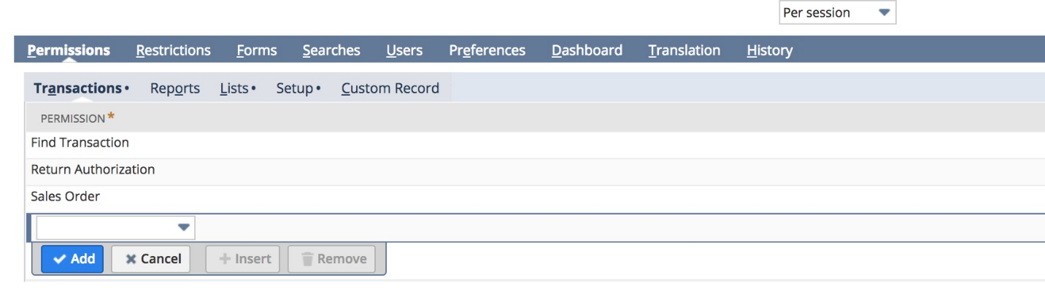
Under the Setup subtab, please add
- SOAP Web services
- Access Token Management
- User Access Tokens
- Log in using Access Tokens
- Custom Item Fields
- Custom Transaction Fields
- Accounting Lists
- Customer Status
- Custom Fields
- Custom Body Fields
- Custom Entity Fields
- Custom Record Types
Under the Lists subtab:
- Customers
- Contacts
- Marketing Campaigns
- Items
- Locations
- Documents and Files
- Employees
- Employee record
- Events
- Vendors

Under the Transaction Subtab:
- Sales Order
- Cash Sale
- Cash Sale Refund
- Item Fulfillment
- Fulfill Sales Orders
- Return Authorization
- Return Auth. Approval
- Find Transactions
- Purchase Order
- Transfer Order
- Inventory Transfer
- Adjust Inventory
- Credit Memo
- Invoice
- Item Receipt
- Transfer Inventory
- Transfer Order

Under “Reports” subtab:
- SuiteAnalytics Workbook

  - Assign the “Management one” Role to the user created in the beginning of the setup that will be used for integration.
Go to Lists > Employees > Employees > edit user > Access tab > Roles subtab.
  - Next to the “Management One” role, there is an Internal ID for this role. Please record the internal ID and paste to the beginning of the document.

Enable Token-Based Authentication
  - Go to Home > Set Preferences > General Tab > Set Defaults and check the box for Show Internal IDs if it hasn’t already been checked.
  - As Administrator, go to Setup > Company > Enable Features > SuiteCloud and check the box for Client SuiteScript if it hasn’t already been checked.
  - Go to Setup > Company > Enable Features > Suite Cloud > Manage Authentication
  - Check “Enable Token-Based Authentication”

Create Integration record

  - Go to Setup -> Integration -> Web Services Preferences
  - Copy the Account ID and paste in the table at the page 1 of this document.
  - Go to menu Setup > Integrations > Manage Integrations
  - Tap the New button
  - Set the name to "Management One Integration". Please make sure to tick the Token-Based Authentication option.
  - If you already have an integration record for “Management One Integration”, you can reuse it by editing the integration and ticking the Token-Based Authentication option and TBA:ISSUETOKEN ENDPOINT and check “User Credential” box.
  - Uncheck TBA: Authorization Flow
  - Uncheck Authorization Code Grant

** Please note: when you click SAVE, the next screen showing the Consumer Key and Consumer Secret will only display once.

  - Please copy Application ID, Consumer Key and Consumer secret values to the beginning of this document.
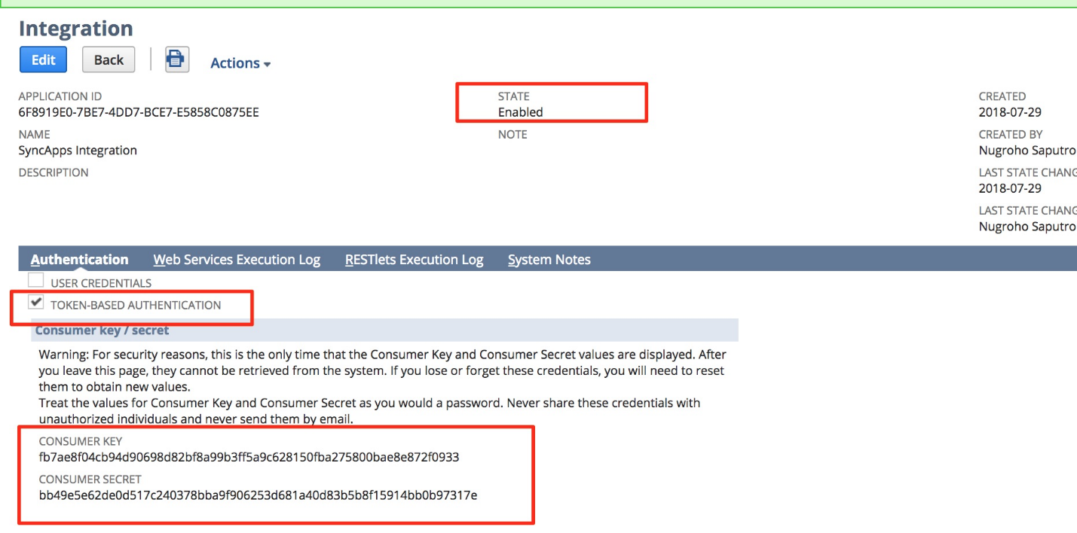

Create an Access Token for the Integration record, User, and Role

  - Go to Setup > Users/Roles > Access Tokens > New.
  - Select the Integration record, User, and Role created or referenced in the previous steps.
    - Application name = Management One
    - User = the user that was created at the beginning of the doc. If the user created did not show up in the list, it means the Management one role was not assigned to this user.
    - Role = Management One
    - Token Name = Management One Integration
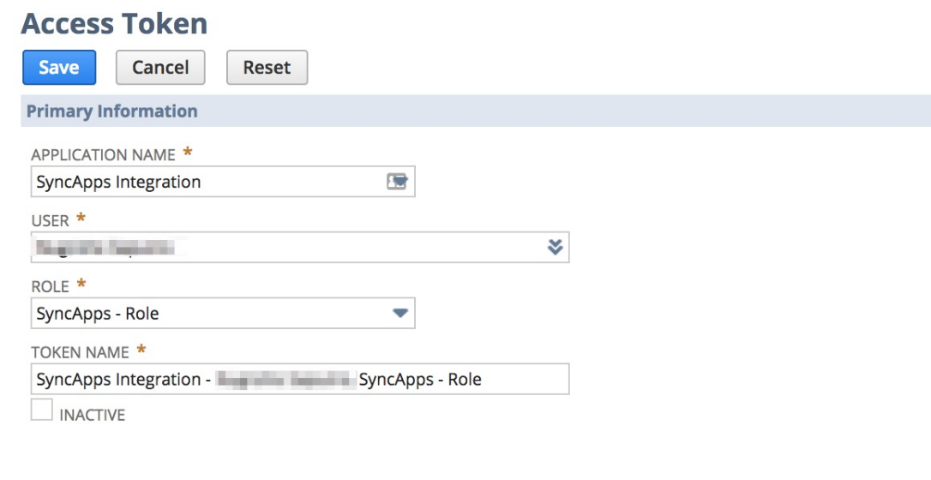
3. Token Id and Token Secret will be displayed (ONLY ONCE) after tapping the save button. Please copy the Token ID and Token secret values to the beginning of this doc.
