How to Edit and Create Management One Audit Reports in Celerant
EDITING THE REPORTS
To access the Management One audit reports in Celerant you follow these steps:
Back Office > reporting > Report Designer > Click Edit > click on the
"Attributes" tab > and add "Type" and whatever else is needed then click
save.
Run the report for the date(s) in question and it can be used to compare.
IF A DAY NEEDS TO BE SENT
If it turns out that a certain day is missing or off, then they can resend
the day in question via Reporting > ManagementOne Export > select the
individual day in question > click "Run"
CREATING A NEW REPORT
To create new Management One audit reports in Celerant you follow these steps:
Path: Back office > Reporting > Reporting > Management One Audit
via Reporting > Reporting > Management One Audit
Back office > Reporting > Report Designer > New/Edit
1) Report Type: Sales
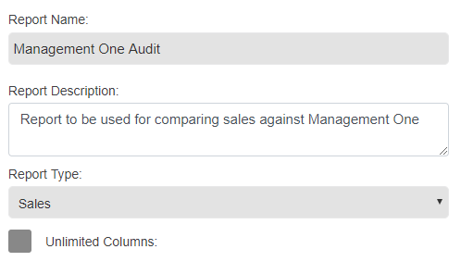
2) ‘Sales Date Type’ = Closed Date
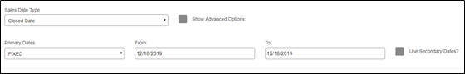
3) Select your stores
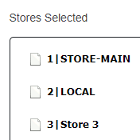
4) Select your attributes (inventory store or receipt store {this is client preference}, etc)
- Inventory store, dept, type, and subtypes 1- 3
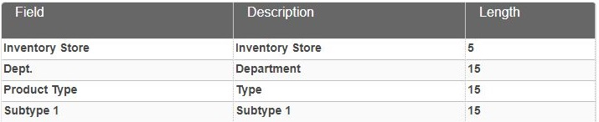
5) Select your Metrics
- Net Retail Sold, Cost of Goods Sold, Net Units Sold, etc
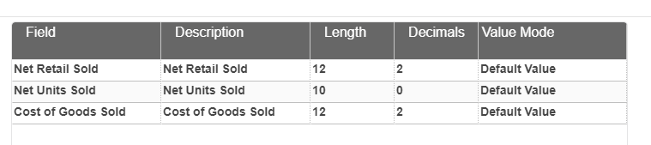
6) Define your grouping by (Inventory Store, etc)
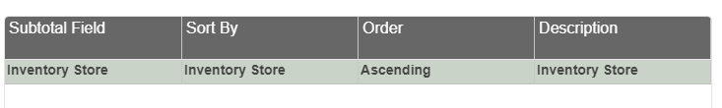
7) Define your filters (inventoried item = ‘YES’ and Exclude X Sales = ‘YES’)
8) Save the report

